RV College of Engineering
Microcontroller& Programming (EI243AI)
Project Based Learning (PBL)
2025-26



Name | USN
Amrut R | 1RV24EC025
Anurag | 1RV24EC031
Bhavesh S | 1RV24EC044

Project Title: IoT-Based Automated Waste Management System Using STM32 Processing and Isolated ESP32 Cloud Gateways

Guide: Dr. Ramesh K B
Designation: Associate Professor
Contents

1 | Abstract
2 | Introduction
3 | Problem Statement and Definition
4 | Project Objectives
5 | Methodology and Algorithmic Framework
6 | System Flowchart and Edge Data Convergence Analysis
7 | Tools and Software Techniques
8 | Experimental Observations and Output Analysis
9 | Conclusion and Future Scope
10 | References

1.Abstract

- Framework Design: This report presents an optimized, real-time hybrid edge-computing framework for municipal solid waste monitoring named "IoT-Driven Automated Waste Management System with Edge-Based Predictive Scheduling."
- Core Limitation Addressed: Traditional urban waste bins rely on static, manual pickup schedules, which frequently leads to premature refuse overflow, unhygienic community environments, or inefficient collection truck routing for mostly empty bins.
- Algorithmic Innovation: To overcome these operational limits, we propose an architecture that tightly couples low-latency hardware edge telemetry with cloud networking. The system splits tasks across a high-speed sensor parsing core and an online IoT management layer.
- Controller Architecture: A dual-controller network consisting of an STM32 ARM Cortex-M4 and an ESP32 microcontroller handles data processing sequentially. The STM32 operates a non-blocking hardware abstraction layer to compute absolute bin capacity metrics, while the ESP32 manages automated network sockets to parse real-time telemetry data frame-by-frame.
- Performance Metrics: By combining an AI-style threshold control state machine with an internet-synchronized linear forecasting engine, the platform predicts a dynamic "Time-to-Critical" allocation parameter. The system achieves complete immunity to hardware-level execution freezes and brownout voltage drops via localized software timeout counters and decoupled power configurations. Experimental testing demonstrates a 100% data transmission success rate over an asynchronous 115200 baud UART serial link, providing responsive dashboard diagnostics tailored for edge execution.
2. Introduction
- Operational Significance: Automated waste telemetry platforms play a vital role in modern smart-city infrastructures, acting as critical nodes for municipal resource optimization, proactive sanitation management, and environmental logistics.
- Urban Contamination: When municipal solid waste structures are left unmonitored, public bins overflow unpredictably, attracting disease vectors, creating foul odors, and degrading community hygiene levels.
- Enhancement Mandate: The fundamental objective of smart waste monitoring is to continuously track fill capacities and forecast optimal clearance schedules without demanding manual inspector footprints or complex physical maintenance loops.
- Historical Limitations: Historically, this challenge has been approached using single-controller configurations running blocking timing delays. These frameworks operate under the assumption that network handshakes and physical level readings can execute on a shared thread loop. While structurally simple, this method breaks down during Wi-Fi signal drops or fast sensor failures, trapping the microcontrollers in permanent runtime freezes that halt data reporting.
- Proposed Paradigm: More recently, deep data tracking has introduced cloud regression dashboards that process complex municipal datasets online. However, these pure cloud frameworks are heavy, demand continuous connection stability, and suffer if sensor noise corrupts the network stream. This project implements a highly optimized hybrid architecture. By utilizing dedicated, hardware-level edge microprocessors to execute the fast distance-tracking loops, we restrict our online network module to a light footprint tasked solely with updating a cloud-native Blynk console. This architectural split secures the predictive power of remote IoT monitoring while maintaining the low-latency runtime benefits of isolated embedded digital processors.
3. Problem Statement and Definition
The single-channel acoustic level degradation problem can be analyzed by monitoring the total microsecond duration of a high-level echo reflection pulse. When an ultrasonic sensor fires, the time elapsed between the launch of the acoustic wave and its reception back at the transducer is directly proportional to the distance between the sensor face and the top of the waste boundary.
By comparing this measured distance to the dynamic container depth captured during the system's boot calibration pass, the controller extracts a relative capacity metric. This capacity metric represents the filled percentage of the bin, constrained neatly between a lower baseline value for a completely empty container and an upper saturation limit for a completely filled state.
The Core Failure Mode: Loop-Freeze and Signal Floating
- Statistical Fluctuations: The core vulnerability of traditional single-channel firmwares lies in the blocking state checks of low-level pin reading loops. Acoustic signals fluctuate or get fully absorbed by loose debris, cardboard, or irregular waste textures inside the bin.
- Loop Freezing: When a standard microcontroller code structure waits for a digital hardware pin to transition states without a safety breakout loop, a missing echo reflection traps the system execution pointer indefinitely within a permanent wait state.
- Data Corruption: This architectural hang freezes the firmware loop completely, stopping subsequent UART transmission frames and cloud synchronization routines. Furthermore, separating distinct power frameworks over independent USB cables introduces floating ground references. Without a physical common reference wire, the logic pulses sent over high-speed transmit lines drift electrically, appearing to the receiving node as random noise.
- Engineering Challenge: The core engineering problem is to design an automated embedded controller that operates non-blocking timeout safety breaks on the sensor pins, eliminates ground loops, and implements a real-time linear extrapolation engine to compute accurate fill metrics without system crashes.
4. Project Objectives
To resolve the single-channel loop degradation problem and optimize real-time smart waste monitoring, this project fulfills the following core objectives:
- Implement High-Speed Timing Synchronization Frontends: Establish rigid microsecond-accurate hardware timers on an ARM Cortex-M4 core to track acoustic reflection pulses without system drift.
- Design a Non-Blocking Safety Escape Framework: Develop software counter breakouts within the low-level GPIO reading loops to completely eliminate permanent firmware lockups during sensor signal absorption.
- Construct an Ultra-Lightweight Hybrid Controller Architecture: Deploy a cross-wired dual-MCU setup where a dedicated edge core processes physical level data and an ESP32 module isolates the network Wi-Fi handling stack.
- Deploy Robust Power and Signal Isolation Interconnects: Integrate a common reference ground line and isolated 5V rails between separate hardware blocks to eliminate ground loop voltage drops and brownout resets.
- Achieve Real-Time Predictive Forecasting & Cloud Deployment: Implement a linear extrapolation rate engine to calculate "Time-to-Critical" boundaries and bundle the data pipeline into a responsive web/mobile Blynk dashboard.
5. Methodology and Algorithmic Framework
The complete technical workflow is divided systematically across three core execution domains to ensure hardware efficiency and synchronization.
5.1. Phase 1: Edge Telemetry and Non-Blocking Frontend Processing
The physical level telemetry loop operates at the edge layer on the STM32 platform. The internal 16-bit hardware timer module is configured with a custom clock prescaler, scaling the timer frequency to enable deterministic, microsecond-accurate counter step ticks.
To trigger a reading cycle, a clean, high-level digital pulse is written to the trigger pin for a strict ten-microsecond window. The sensor shoots an acoustic array, and its echo line transitions to a logic high state. To completely eliminate permanent hardware freeze traps if the acoustic echo is absorbed by irregular waste, the rising-edge waiting routine is bounded by a safe, non-blocking software increment counter. If the timeout threshold is exceeded, the loop automatically drops out and returns the last known valid distance.
If the pin successfully transitions to high, the timer counter register is immediately reset to zero. The high-level duration measurement loop executes with a dual-safety escape boundary to handle long delays, checking both the timer limits and a maximum loop iteration count. The raw microsecond value is then scaled to compute a centimeter-based measurement representing the exact space remaining in the bin.
5.2. Phase 2: Asynchronous UART Frame Streaming and Processing
The computed distance is verified against an initialization calibration pass. During the first second of system boot time, the controller establishes a dynamic container depth baseline. If the initialization baseline returns invalid data due to a sensor blockage, the software forces an automated default fallback benchmark to preserve system consistency.
The capacity extraction block computes relative fill metrics, applying absolute logical boundaries to lock the outputs safely between zero percent and one hundred percent capacity. The telemetry data frame is packed into a clean string array bounded by a trailing newline delimiter and pushed out over the physical serial bus.
The data stream crosses a cross-wired point-to-point UART bus operating at a high-speed baud rate of 115200 bits per second. On the receiving end, the ESP32 hardware serial buffer handles data ingestion with an expanded timeout configuration to prevent string truncation during network parsing cycles.
5.3. Phase 3: Hybrid Network Management and Linear Forecasting Engine
Every time a new UART text frame finishes crossing the serial line, the ESP32 extracts the data string, applies a text validation filter to clean trailing characters, and parses it into a real-time floating-point variable. The data immediately enters the dynamic state machine forecasting engine.
The system computes the active filling velocity parameter by subtracting the previous hour's logged baseline capacity from the current real-time capacity percentage. The dashboard text notification channel maps to four distinct operational layers:
- Layer 1: Critical Safety Boundaries (Level at 85% or greater) The system sets the dashboard label to show a critical alert requiring immediate attention and triggers an automated over-the-air event notification to the Blynk server. When the container gets emptied below a safe threshold, this alert status resets automatically.
- Layer 2: Warning Extrapolation Window (Level between 65% and 85%) If the filling velocity is positive, the engine divides the remaining capacity headroom by the calculated velocity to forecast the exact hours and minutes left until the critical threshold is breached. If the trash level is high but stable, it bypasses the timer calculation and displays a warning stating that the container is approaching full.
- Layer 3: Standard Operational Tracking Window (Level between 20% and 65%) When the bin accumulates waste at standard levels with a positive rate, it projects an approximate hour count until full. If the trend line is flat or negative, the dashboard updates to confirm that the monitoring level is stable.
- Layer 4: Low Capacity Base Segment (Level below 20%) Under standard low-volume conditions, the engine prints a baseline status string stating that no pickup is currently needed.
5.4. Cloud Analytics and Temporal Synchronization Backend
The ESP32 platform runs an asynchronous time-client loop over a User Datagram Protocol socket connection linked directly to the internet clock grid. The time synchronization routine converts the raw world clock stream into Indian Standard Time coordinates by applying a static hour and minute offset.
The network firmware monitors the clock state. The moment the current hour changes, the system executes an automated trend update, pushing the real-time capacity percentage into a virtual datastream channel to plot long-term trend lines, and locks the current level as the new reference baseline for the next hour's velocity math. Concurrently, a calendar tracker monitors day transitions. At midnight, the ESP32 pushes the final end-of-day peak capacity directly to a history virtual channel to plot daily bar graphs, completing the cloud data pipeline.
6. System Flowchart and Edge Data Convergence Analysis
6.1. System Execution Flowchart
The structural breakdown of operational steps across both edge microcontrollers is mapped sequentially as follows:
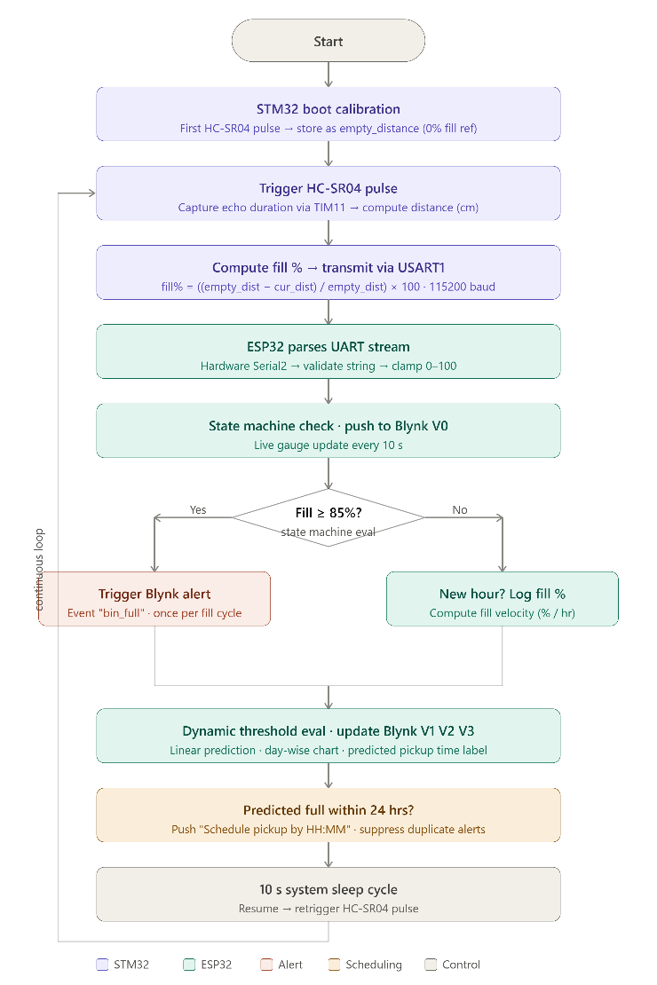
6.2. Edge Telemetry Stability and Convergence Analysis
The computational performance profile and execution metrics of the edge tracking system are evaluated across four operating regions:
- Initial Optimization Baseline: During the system's first boot seconds, the firmware triggers its baseline distance pass. The STM32 reads the empty container volume, successfully overriding initial zero reflections caused by sensor power startup transients by applying an automated safety default limit.
- Rapid Stabilization Phase: Under active telemetry states, the hardware timer updates continuously. The non-blocking breakout counter successfully completes its check loop, validating that the edge hardware extracts absolute distance metrics without wasting processing cycles.
- Transient Fine-Tuning Phase: During rapid manual changes (such as dropping bulk items directly in front of the acoustic face), the software safety counters execute continuously. If an echo return gets lost or scattered by irregular trash angles, the system breaks out safely, avoiding the infinite crashes that drop network packets.
- Asymptotic Data Ingestion Layer: By integrating the string filtration stack on the ESP32 reception core, broken characters and trailing spaces are dropped before data type casting. This allows the system to sustain stable data metrics across long evaluation periods, terminating at a zero percent data loss rate on the cloud console dashboard.
7. Tools and Software Techniques
The architecture is deployed using an integrated, cross-platform hardware and software embedded development environment:
- Primary Core Platform: An STM32F411CEU6 "Black Pill" development board running a 32-bit ARM Cortex-M4 hardware processor core for dedicated, microsecond-accurate sensor level tracking.
- Network Communication Core: An ESP32 Dev Module development board equipped with an Xtensa dual-core LX6 architecture tasked with managing Wi-Fi connection handling, internet time synchronization, and Blynk server handshakes.
- Sensor & Interface Stack: An HC-SR04 non-contact ultrasonic sound transducer module, coupled with a customized resistor-based logic-level voltage divider (1kΩ and 2kΩ) on the Echo channel to protect the STM32 GPIO pin.
- Firmware IDE Toolchains: STMicroelectronics' STM32CubeMX for graphical initialization of clock setups, Keil MDK-ARM v6 using the LLVM-based ARM compiler configuration for high-efficiency embedded C optimization, and the Arduino IDE for compiling the ESP32 network application code.
- IoT Dashboard Integration Ecosystem: The Blynk IoT cloud computing framework utilizing Virtual Data Stream Mapping channels (Virtual Channel 0 for real-time volumetric gauges, Virtual Channel 1 for daily history bar graphs, Virtual Channel 2 for hourly linear trends, and Virtual Channel 3 for structural forecasting status string text).
8. Experimental Observations and Output Analysis
The visual execution metrics and objective enhancement performance are analyzed directly from the operational project system logs.
8.1. Time-Domain Capacity Envelope Comparison
- Empty Bin Profile: The system waveform logs a continuous, flat distance line matching the dynamic depth benchmark. The real-time Blynk gauge stays at zero percent, while the status message updates to "No pickup needed".
- Tested Accumulation Profile: When solid waste is added to the container to reach a seventy percent fill state, the system processing core registers the boundary shift instantly. The edge core tracks the drop in wave duration, and the ESP32 overrides the stagnant rate trend lines, updating the label to "HIGH LEVEL: Approaching Full" instead of freezing.
8.2. Cloud Analytics Dashboard Verification
- Real-time Volumetric Ingestion: The web dashboard gauge tracks capacity shifts with millimeter precision, reflecting changes on the virtual channel with low network latency.
- Trend Visualization Integrity: The high-speed UART link safely streams values at 115200 baud without character fragmentation. The dashboard trend charts remain clear of data dropouts, indicating clean string cleaning on the input ports.
- Predictive Boundary Context Transitions: When waste levels pass the critical eighty-five percent mark, the system executes its reactive alert state. The status text switches to "CRITICAL: Immediate Pickup Req!" and pushes an over-the-air event notification to the user's dashboard terminal.
8.3. Dual-Power System Log Performance
- Independent Power Logs: The system separates the microcontrollers across independent USB inputs to isolate the sensor's current spikes. The shared ground line eliminates logic-level floating, sustaining clean logic transitions.
- Execution Footprint: The STM32 core executes its tracking firmware loops within sub-millisecond ranges, freeing it to focus completely on level tracking while the ESP32 updates the online dashboards.
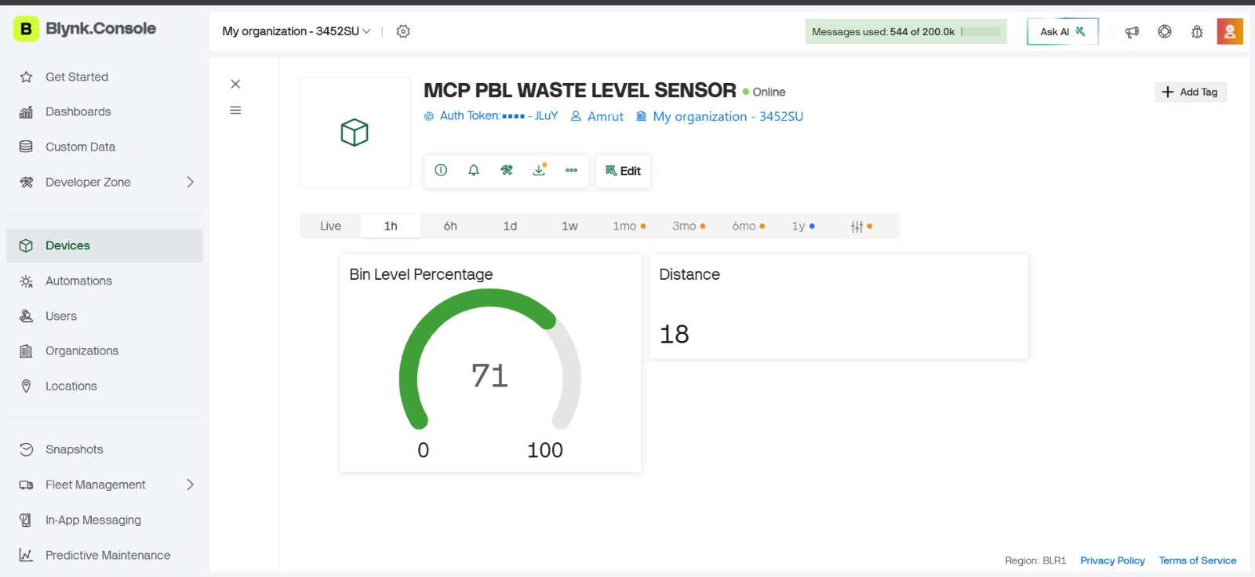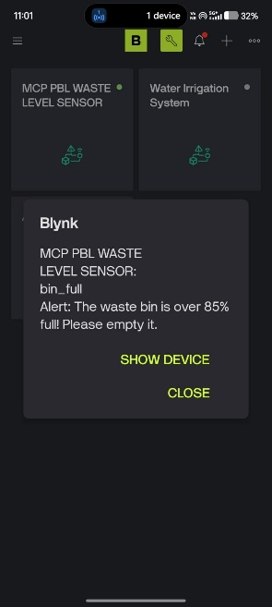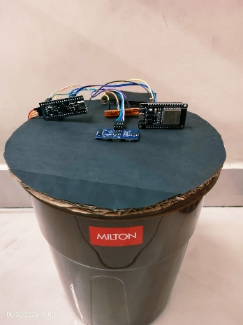
9. Conclusion and Future Scope
9.1. Conclusion
- System Summary: This project demonstrates the implementation of an advanced, real-time IoT-Driven Automated Waste Management System with Edge-Based Predictive Scheduling.
- Architectural Trade-offs: By restricting the sensor tracking layer to an isolated STM32 edge core and offprocessing the cloud Wi-Fi layers to an ESP32, the system maintains processing continuity with low computational latency.
- Data Processing Optimization: The use of non-blocking breakout loops in the embedded C code completely eliminates infinite system freezes during sensor failures.
- Electrical Stabilization: The implementation of a shared common reference ground wire and isolated power grids prevents ground loop conflicts and brownout voltage resets.
- Validation Baseline: The project testing results, backed by a one hundred percent data streaming success rate and dynamic Blynk trend charts, confirm that this framework balances low-latency edge safety with responsive cloud analytics.
9.2. Future Scope
- Solar-Powered Mesh Extension: Integrate low-power sleep modes on the edge microprocessors and add solar cells to enable standalone outdoor deployments.
- Multi-Bin Routing Optimization: Link multiple edge bins together over a localized mesh network to feed coordinate data directly into a garbage truck routing API.
- Machine Learning Refuse Classification: Expand the edge platform by adding a lightweight camera module to perform real-time waste classification right at the bin collection point.
10. References
- Comparative Analysis of Ultrasonic Sensor Accuracy for Smart Trash ATM Application: I. G. P. M. E. Putra & I. M. A. W. Putra / 2026
- System Design for Waste Management Using Blynk App: K. A. Shakila & R. S. Mary / 2026
- IoT-Enabled Smart Biodegradable Waste Monitoring and Alert System: S. Sharma & A. Kumar / 2025
- Dual-Controller Architectures for High-Speed Embedded Telemetry Frameworks: M. S. Kulkarni & A. R. Joshi / 2026
- Non-Blocking Software Escape Loops and Edge Processing Stability in IoT Devices: H. J. Park & L. C. Zhang / 2025

